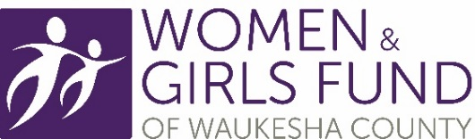
Grant Letter of Intent APPLICATION
Grant Year: May 1, 2024 – April 30, 2025

Please note: All submissions must demonstrate services to women and girls.

ORGANIZATION NAME DATE
APPLICANT/CONTACT PERSON PHONE
ADDRESS
CITY/STATE/ZIP EMAIL
REQUEST AMOUNT TOTAL PROGRAM/PROJECT COST
PROGRAM/PROJECT NAME
STARTING DATE OF PROGRAM/PROJECT (OR LIST AS ONGOING)
ORGANIZATION is 501c3 ☐ EIN NUMBER
PROGRAM/PROJECT PRIMARY FOCUS: (Select one) ☐ Health and Well-Being ☐ Self-sufficiency ☐ Empowerment
☐ Mental Health (special initiative, one-time 2024 grant allocation)
AT LEAST 50% OF CLIENTS SERVED ARE WOMEN AND GIRLS: ☐
PROGRAM/PROJECT PRIMARY CLIENTS: ☐ Women ☐ Girls
Overview of request (1-2 sentences AND no more than 100 words):

Need(s) addressed by program/project. Provide specific evidence and identify at least one source (1-2 sentences AND no more than 100 words

Program/project description (1-2 sentences AND no more than 100 words):

Provide program primary outcome, the indicator for the specific outcome and how it will be measured (1-2 sentences AND no more than 100 words):

Target population served and number of projected individuals by program/project.
- Must provide the number of women and/or girls in Waukesha County to be served (1-2 sentences AND no more than 100 words):

If you do not receive the full amount requested, how would the program/project continue?
Financial support for the program will come from continuous fundraising initiatives, which encompass special events, individual contributions, and a share of the state-wide grant funding designated for Waukesha County.

Grant Timeline:
- Letters of intent are due Friday, January 26, 2024 by Noon. to:
Sue Juntunen
contact@wgfwaukeshacounty.org

- The Women and Girls Fund of Waukesha County Board of Directors will review all letters of intent and notify organizations if the program/project has or has not been selected to submit a full proposal.
  - Organizations will be notified of the Women and Girls Fund decision by Tuesday, February 20, 2024.

- Organizations invited to submit a full proposal for the selected program/project will be provided a list of required documents for submission.
  - Full proposals are due Wednesday, March 1, 2023 by Noon.

Questions/Concerns:

Contact Sue Juntunen at contact@wgfwaukeshacounty.org or at 262-875-3126.

